The project will be optimised for mobile and the application will respond to different screen sizes. We have identified the following requirements for the project.

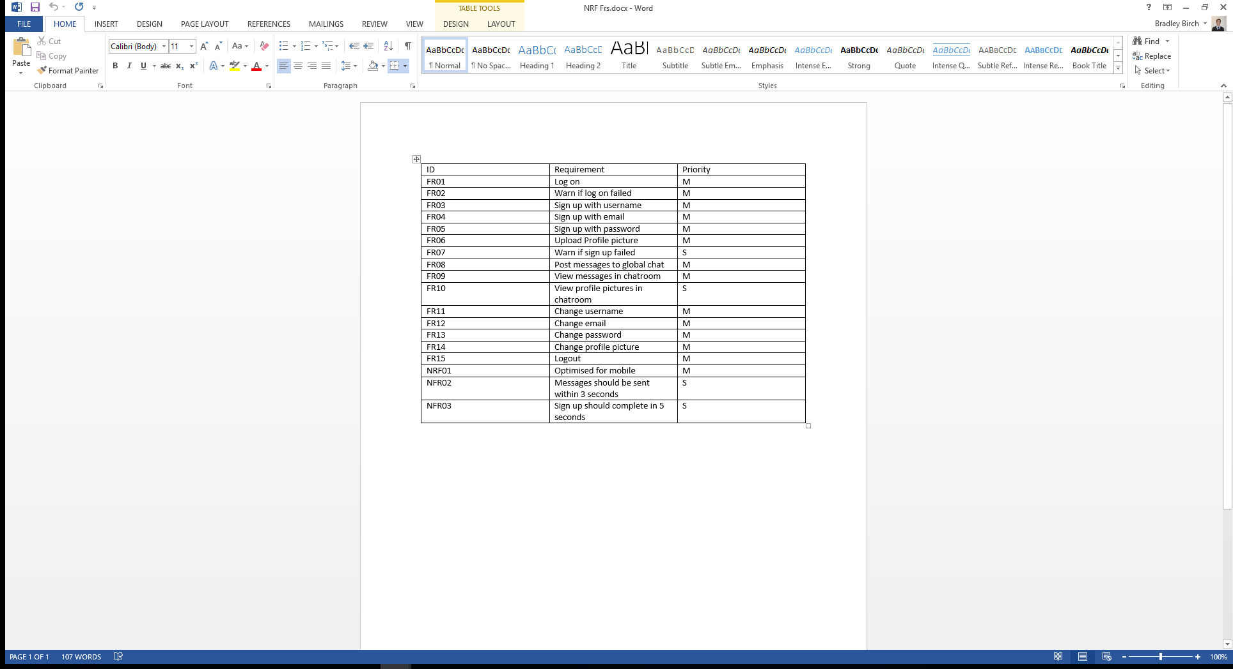

Figure : Project requirements

With these requirements in mind, we have created the following designs.

**Mobile**

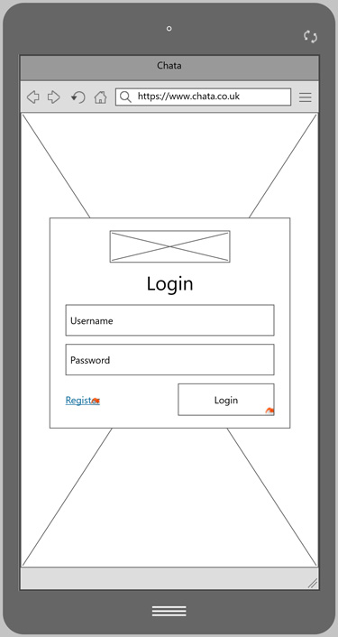

* Minimal input so that virtual keyboard does not cover any fields
* Validation will colour the input box and a message will occur above the fields
* Button to navigate to the sign up screen
* Large call to action button to login

Figure 1: Login screen

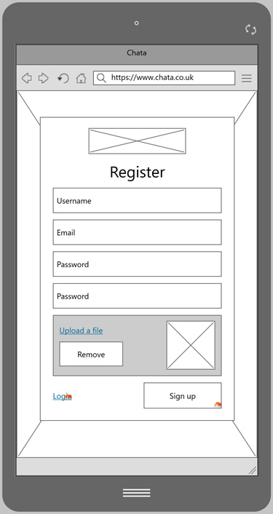

* Minimal fields to sign up
* Password confirmation box
* Validation will colour the input box and a message will occur above the fields
* Button to navigate to the login screen
* Large call to action button to sign up

Figure 2: Register screen

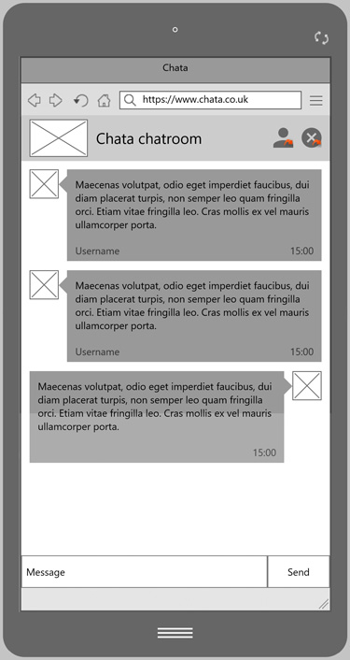

* Top inline navigation bar takes you to profile page and logout
* Clean page with little clutter allows for an easy user experience
* Users can see the profile pictures of different users
* Clear input and send button
* Message failure message will occur as a pop up above the send message

Figure 3: Chatroom screen

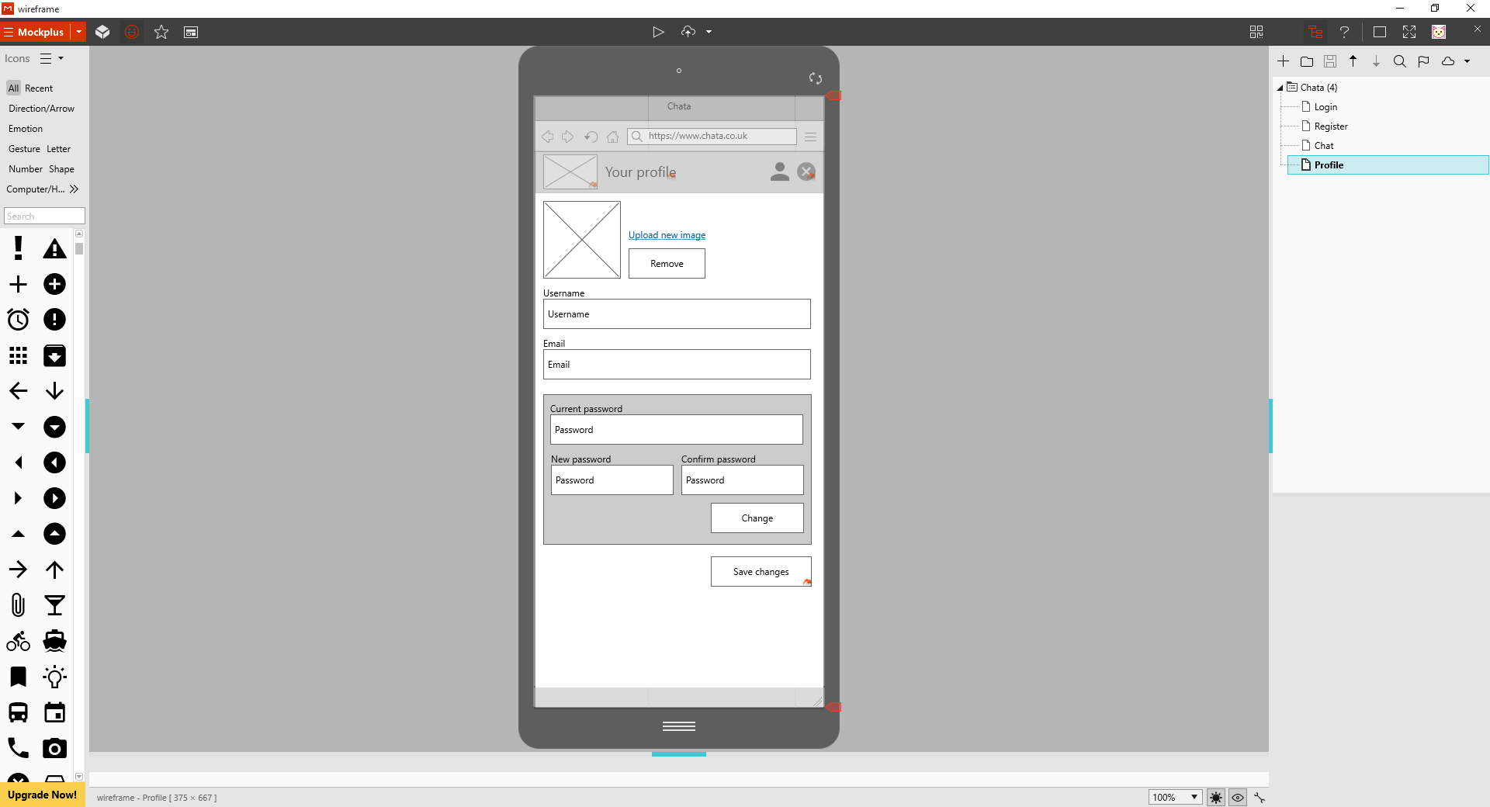

* Top inline navigation bar takes you to chat and logout
* Validation will colour the input box and a message will occur above the fields
* Save will return you to the chat room
* Minimal amount of fields

Figure 4: User screen

**Desktop**

The wireframes for desktop are very similar to the ones for mobile. The enhanced screen size allows extra space on the page, meaning more flexibility for content on the application. The majority of the functional requirements needed for the application are already explained in the mobile wireframes as we are following mobile first design, so the desktop ones are quite self-explanatory. The additional elements added will be explained below. There are minor notes below reflecting any differences between the two device sizes.

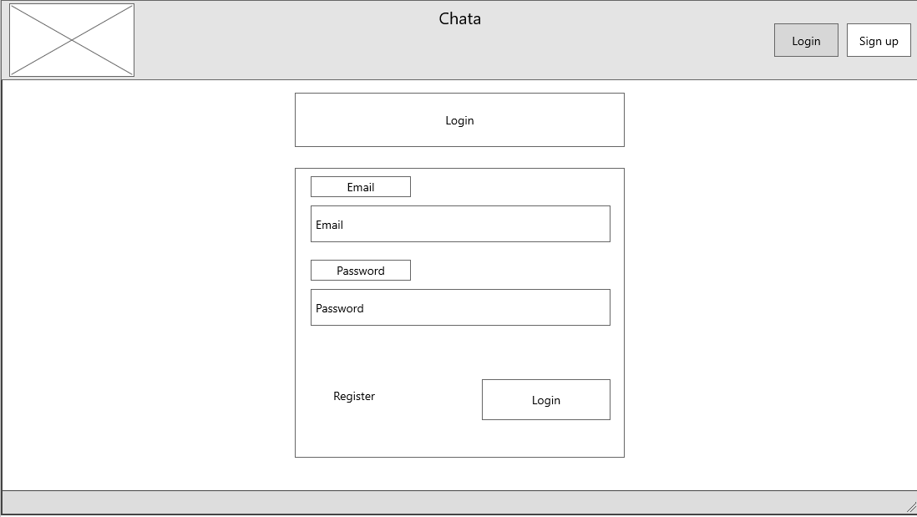

Figure 1: Login screen

* The sign up and login buttons are duplicated to the top nav to give the user a choice. The rest of the login form is in the same format as it is on a mobile device.
* Labels have been added due to the additional room on the page, meaning the option of using a placeholder attribute in mobile can be removed from the inputs.

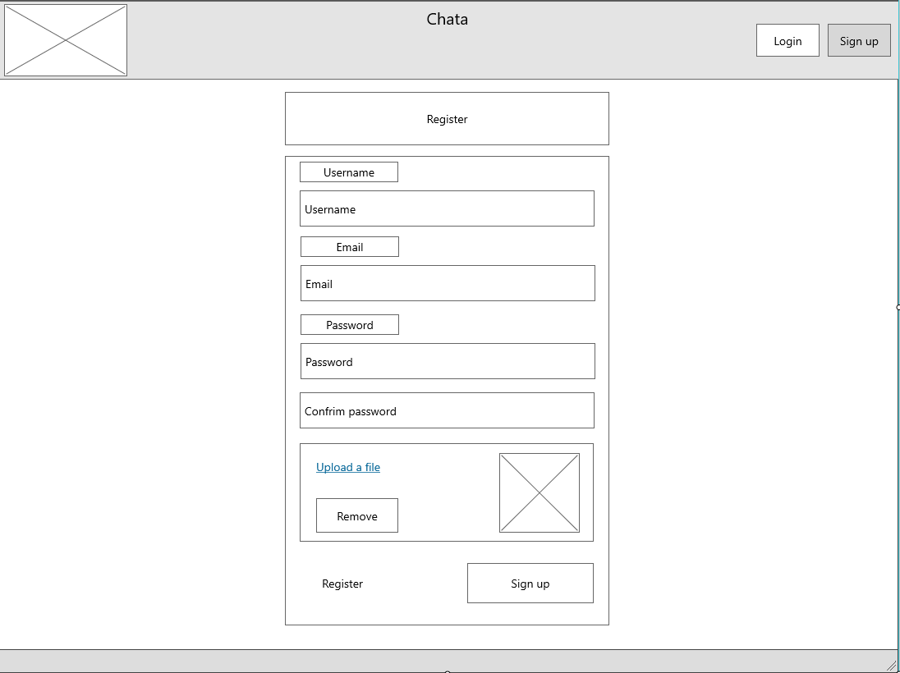

Figure 2: Register screen

* The layout is again similar to mobile. No additional functionality is added at this point

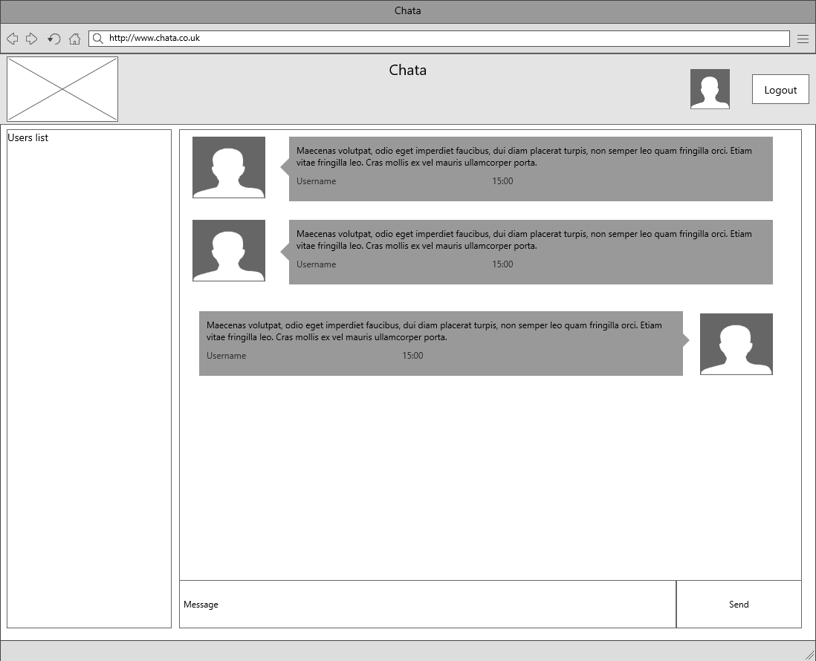

Figure 3: Chatroom screen

* The extra size allows there to be a user list. This will display the users who are live.
* The icon along the top navigation that takes you to the live chat will change to a slightly bigger version.

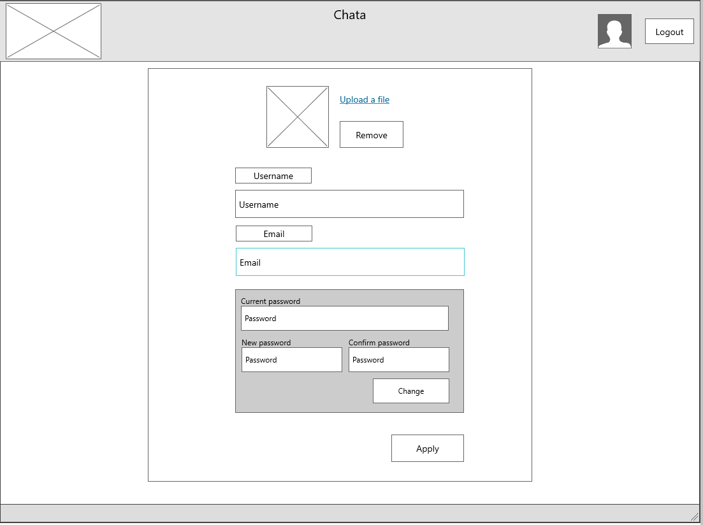

Figure 4: User screen

* Similar to the mobile version, the navigation bar will still allow you to log out and view the chat.